**INFORMATIC PRACTICES PROJECT CUM HHW**

• project on performance or academic growth of a child from class 6th to 10th .

• Steps involved

* First, we have made gather the data in the form of table (i.e. Data frame)
* Then we have visualise the dataframe in the form of bar graph .
* 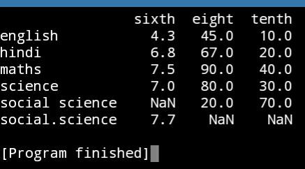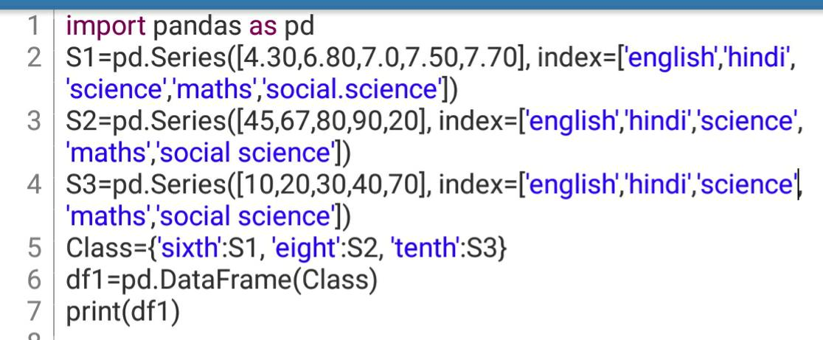Note: all the data taken here is imagery and all the programs are with their respective syntax and output.

